|  |  |
| --- | --- |
| Workshop | 1 / 2 |
| Duration | 3 days |
| Topic | Shopping Card |
| Learning Outcome | LO3 |
| Total | 100% |

1. Create web application using Struts 2 Framework (mandatory, failure if ignoring this requirement)
2. 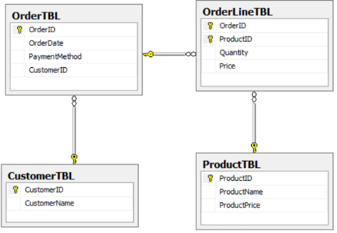Design a database for sale system (10%)

1. When user access to the system. The system redirect user to /product to display the list of products (30%)

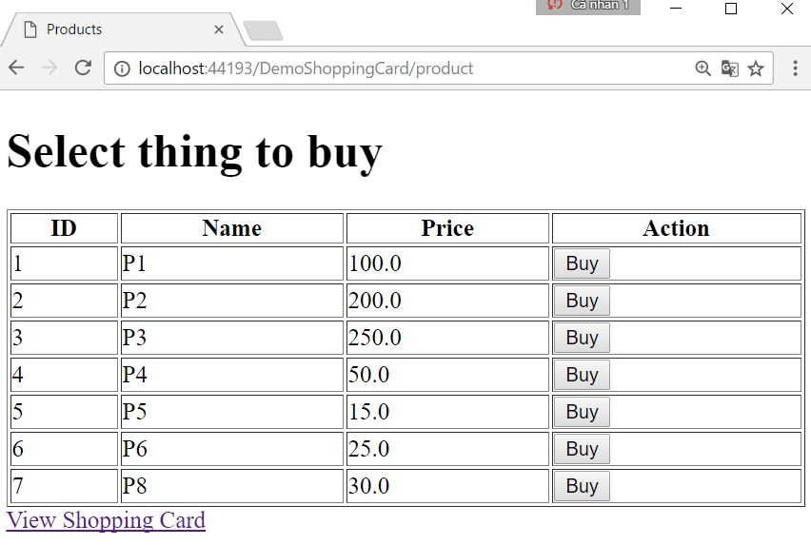

1. If user would like to buy a product, he/she clicks corresponding ‘buy’ button. For each click, there is a product will be added to the shopping card. (5%)
2. User can click to the hyperlink to see what he/she selected. System displays selected items (25%)

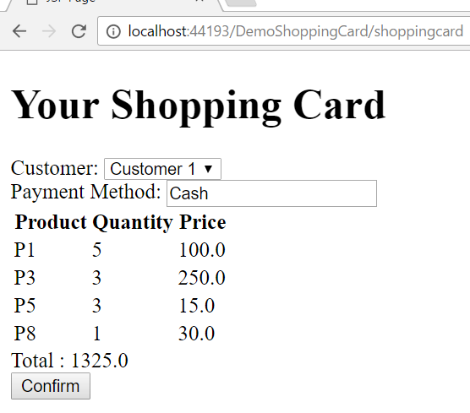

1. User will select customer who makes order and fill in the Payment method. When user clicks confirm button. An order and its order lines will be added to database (Every command must be bounded by the transaction). (20%)